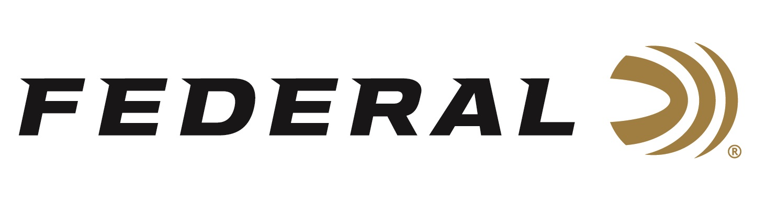

FOR IMMEDIATE RELEASE

Federal and Reeds Sign Gould Brothers

ANOKA, Minnesota – May 4, 2020 – Federal Ammunition and Reeds Family Outdoor Outfitters partner together to sponsor the incredible exhibition shooting duo, the Gould Brothers. The brothers have been entertaining fans for more than a decade with their one of a kind trick shooting shows and fun YouTube videos. Steve and Aaron Gould will now entertain crowds throughout the United States flying the flags of two Minnesota mainstay outdoor companies.

Following in the footsteps of legendary exhibition shooter Tom Knapp, Steve and Aaron Gould have picked up that mantle and continue performing trick shots that amaze audiences with their energetic live shows. “We watched Steve and Aaron hone their craft over the years and Federal is excited to join forces with them,” says Jason Nash, Vice President of Marketing at Federal Ammunition. “We are happy to watch them make incredible shots with Minnesota made products.”

“There is nothing like attending a live show in person,” says Adam Arnold of Reeds. “The Gould Brothers are great at entertaining and engaging with audiences with an unmatched in-person experience. It’s amazing to see how they have included their live show interaction and fun into their YouTube channel to make shooting fun and educational. Reeds is excited to cultivate and grow their shooting creativity and innovation.”

“Pulling off incredible shots requires incredible ammunition and we couldn’t be more excited to take our careers to the next level with Federal. Our dream to become professional exhibition shooters started at the annual Reeds Gun Fair event, watching an incredible man shoot Federal ammunition and now, here we are, working with both Federal and Reeds. A dream comes true! We are so excited to represent both iconic Minnesota companies that have been serving outdoor enthusiasts and shooters for more than a combined 150 years.”

Reeds Family Outdoor Outfitters is one of the oldest, most renown outdoor outfitters in the nation. Family-owned, customer-driven for over 65 years, Reeds offers complete hunting, fishing and apparel departments at ReedsSports.com. Although Reeds is tucked away in the quaint Northwoods community of Walker, Minnesota, on the shores of one of America's top fishing lakes, beautiful Leech Lake, but is an award-winning top national retailer.
Federal ammunition can be found at dealers nationwide or purchased online direct from Federal. For more information on all products from Federal or to shop online, visit www.federalpremium.com.

Press Release Contact: JJ Reich
Senior Manager – Press Relations
E-mail: VistaPressroom@VistaOutdoor.com

About Federal Ammunition
Federal, headquartered in Anoka, MN, is a brand of Vista Outdoor Inc., an outdoor sports and recreation company. From humble beginnings nestled among the lakes and woods of Minnesota, Federal Ammunition has evolved into one of the world's largest producers of sporting ammunition. Beginning in 1922, founding president, Charles L. Horn, paved the way for our success. Today, Federal carries on Horn's vision for quality products and service with the next generation of outdoorsmen and women. We maintain our position as experts in the science of ammunition production. Every day we manufacture products to enhance our customers' shooting experience while partnering with the conservation organizations that protect and support our outdoor heritage. We offer thousands of options in our Federal Premium and Federal® lines-it's what makes us the most complete ammunition company in the business and provides our customers with a choice no matter their pursuit.

